Day 3

1. Connect two router.

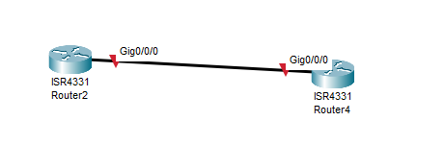

1. Connect router with switch.

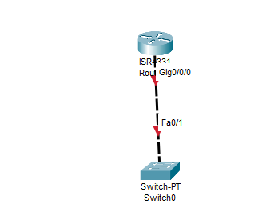

1. Connect Router with PC

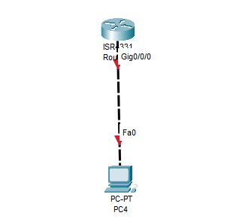

1. Connect PC with a switch

